**Week 4 Assignment**

Justin Stewart

CST499: Capstone for Computer Software Technology

Prof. Elchouemi

3/27/2023

**Implementation Phase Experience**

**Introduction**

The Online Course Enrollment System is an important system that aims to allow students to register and drop courses easily, as well as allow administrators to manage courses and enroll students. This paper summarizes the experience of going through the implementation phase of such a system, from conception to the final stages of development.

**System Requirements Specification (SRS):**

The first step in developing the system was to create an SRS document that outlined the requirements of the system. This document included functional and non-functional requirements, use cases, and associated diagrams. This was a new approach to development for me, as I had never fully planned a system before developing it, but it allowed for a clear understanding of the system requirements.

**Database Design:**

Once the SRS document was complete, the database design was created. However, during the development phase, it was realized that the initial database design needed to be adjusted to accommodate development. I feel this is a common issue in development, and I handled it the best I could, given the circumstances of a poor initial design.

**Week One of Development:**

The first week of development was truthfully fairly straightforward for me. I was able to create the landing page, registration page, and login page for two types of users: administrators and students. This was a significant accomplishment and allowed for a solid foundation to be built for the system.

**Week Two of Development:**

The second week of development was significantly more challenging. In this week, I was tasked with creating a course registration page that allowed administrators to add and remove courses from the course catalog. Additionally, students were able to register and drop courses on their own student registration page. This task proved to be extremely difficult and involved completely reworking the design of the system, which is shown is the Screenshots section below.

**Challenges and Successes:**

One of the biggest challenges during the development phase was getting the correct logic to determine when users should be allowed to register for courses. This involved determining if a course was full and adding students to the waitlist if necessary. If a spot opened up in the course, the first student on the waitlist would be enrolled. Despite the difficulties, I was able to create a functioning system, but with one error. When a student registers for the final spot in the course, they are registered into the course and the waitlist, which still needs to be fixed.

**Conclusion:**

In conclusion, the experience of going through the implementation phase of an Online Course Enrollment System was challenging but rewarding. I was able to create a functioning system that met the requirements outlined in the SRS document, and while there is one error, the overall system worked flawlessly, which was difficult to achieve while maintaining the integrity of the data across multiple tables. Overall, I learned a great deal about development and the importance of creating a strong foundation for a system.

**Screenshots of Functionalities**

**Updated Database Schema:**

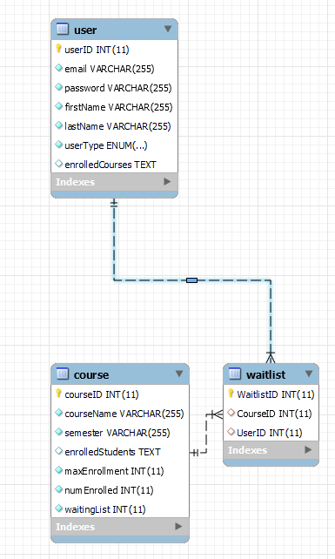

**Home Page:**

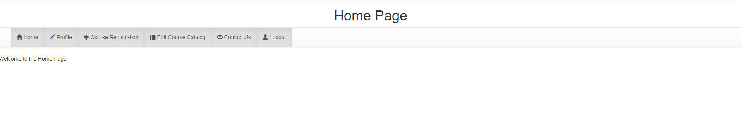

**ContactUs Page:**

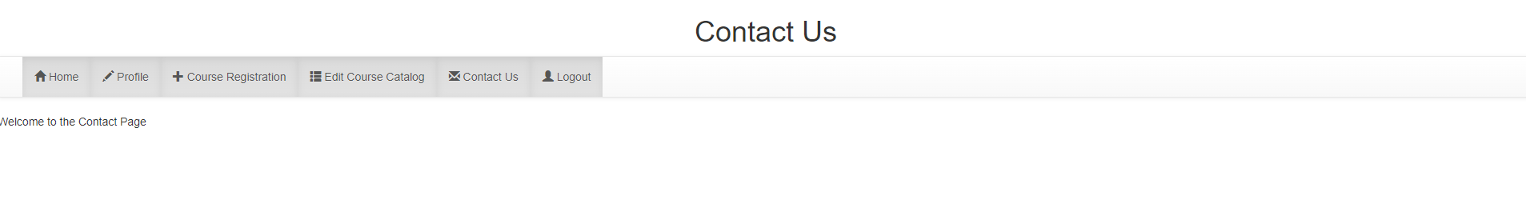

**Registration Page (ADMIN):  
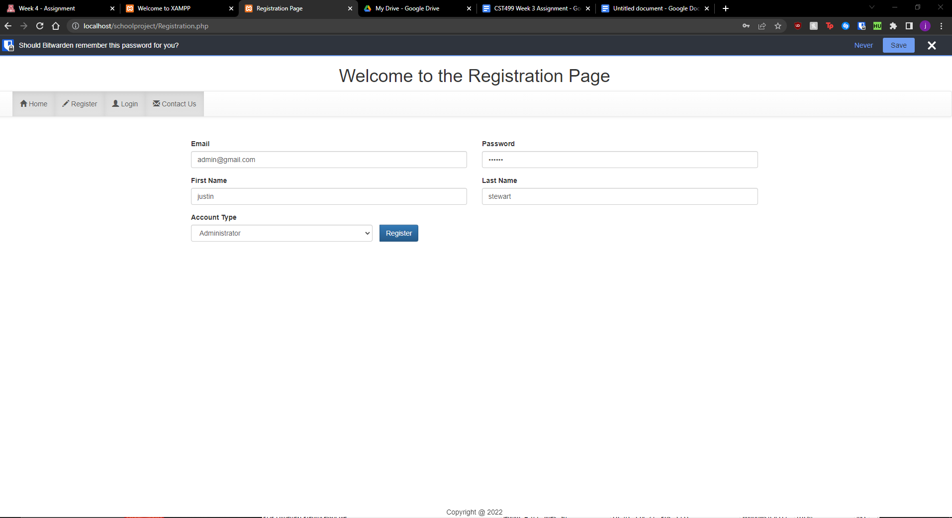**

**Result:**



**Registration Page (STUDENT):**

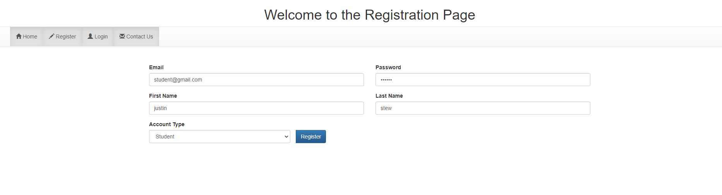

**Result:**

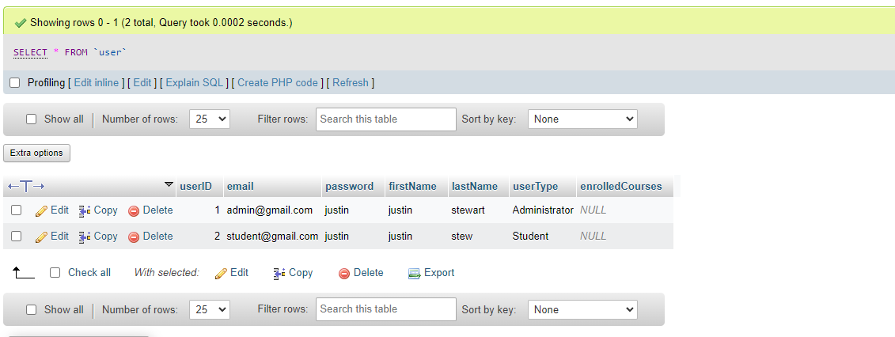

**Profile Page:  
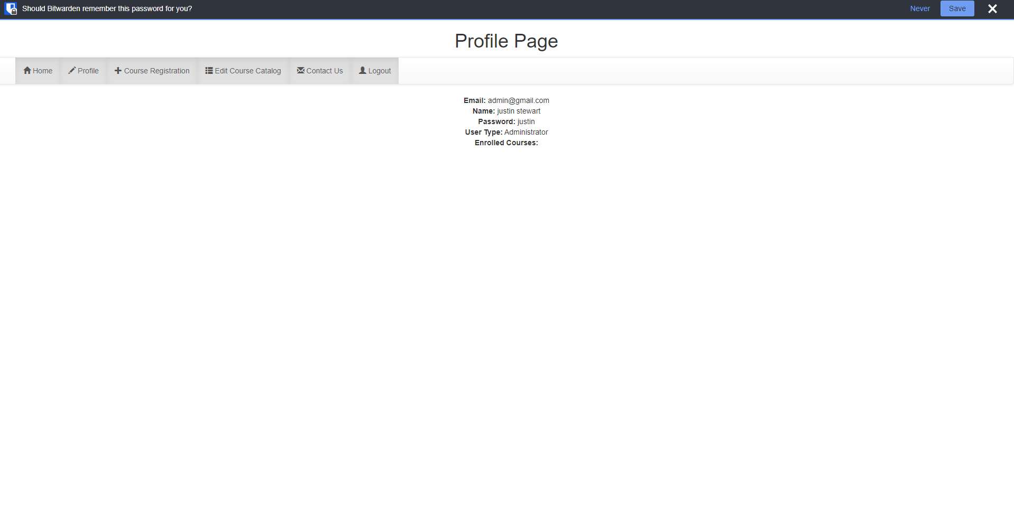**

**Edit Course Catalog(ADD):**

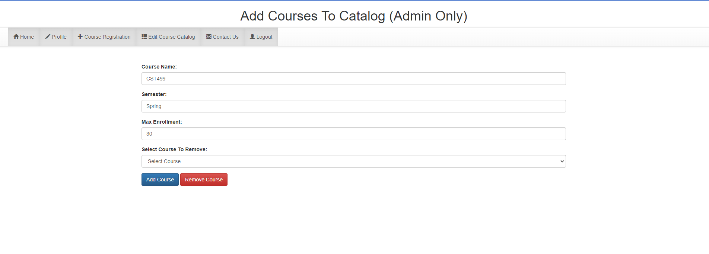

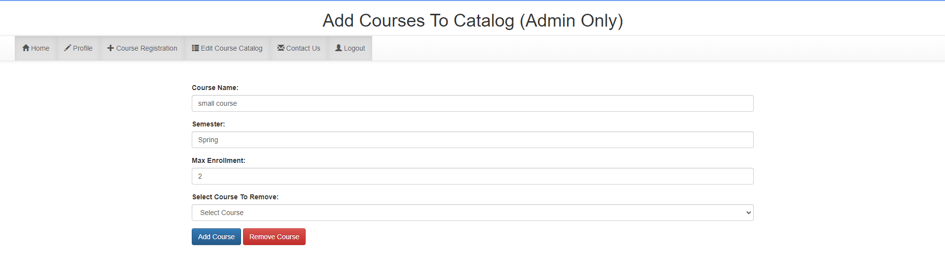

**Result:**

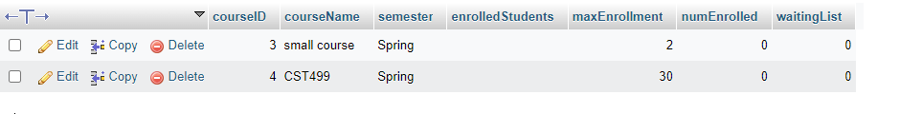

**Edit Course Catalog(Remove):**

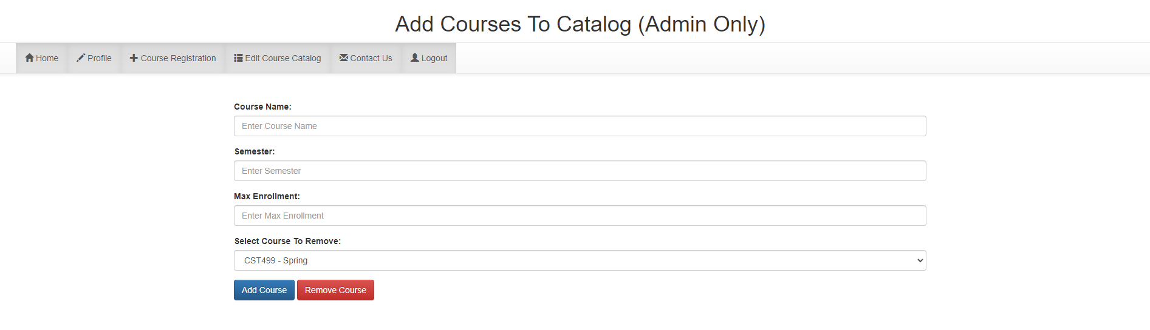

**Result:**



**Course Registration:**

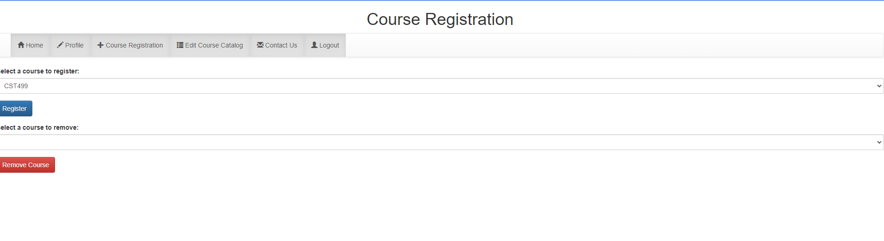

**Result:**

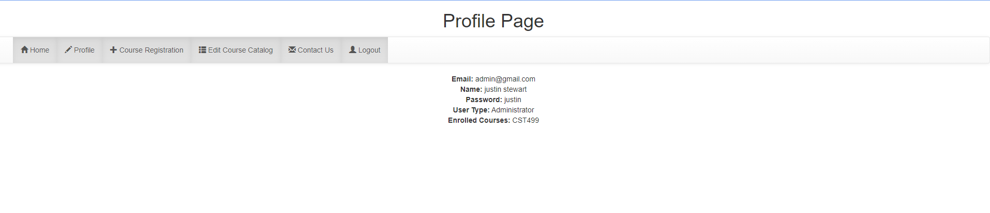

**Users Cannot Enroll In Same Course:**

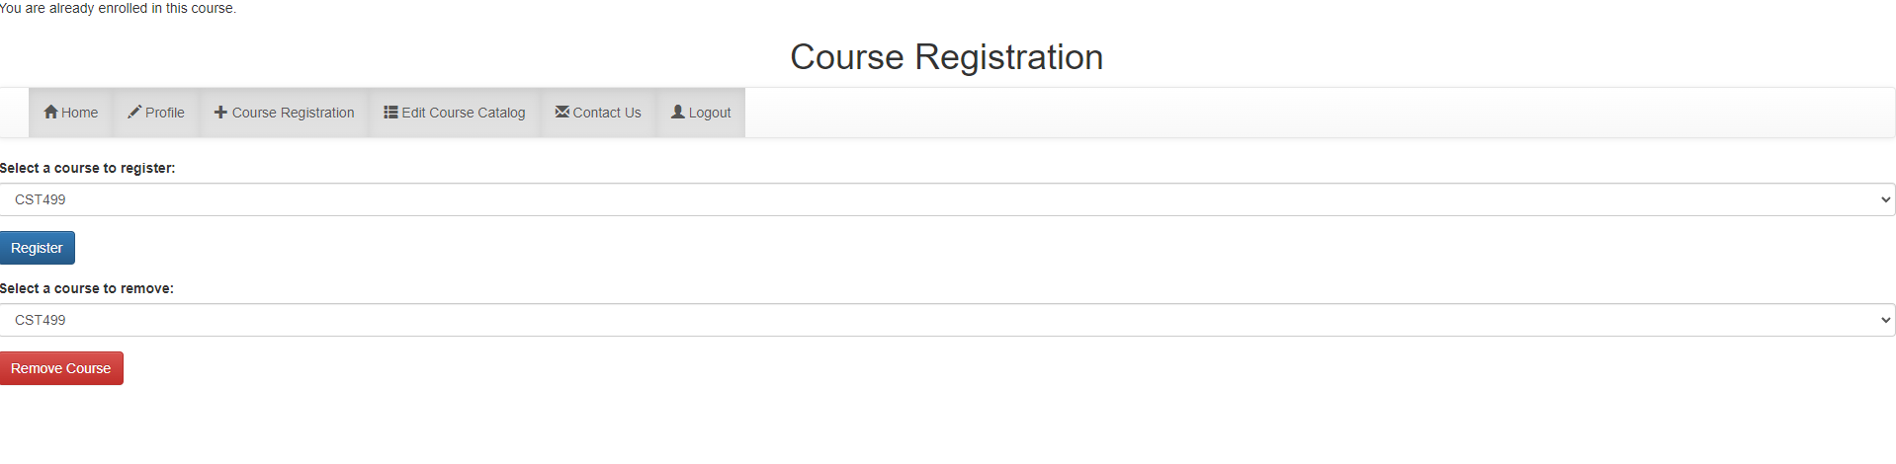

**Waitlist (Registering for Full Course):**

**Note: Both accounts registered to the Small course to fill it and add to waitList.**

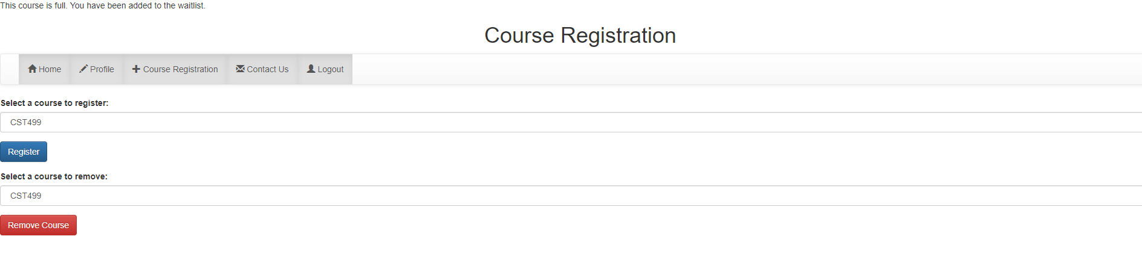

**Result:**

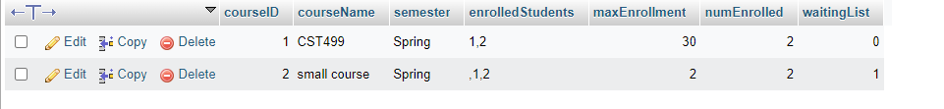



**One Student Removes The Course:**

**Note: The system enrolls the first waitlisted user once someone withdraws.**

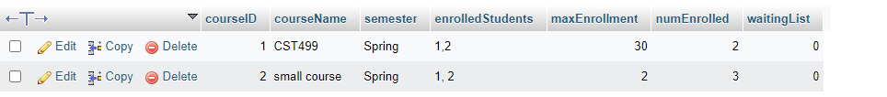

**Waitlist Emptied From Enrolling Student:**

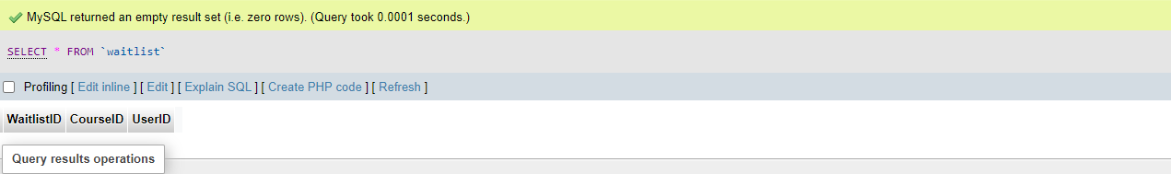

**Source Code Screenshots**

**Config.php (DB Connection):**

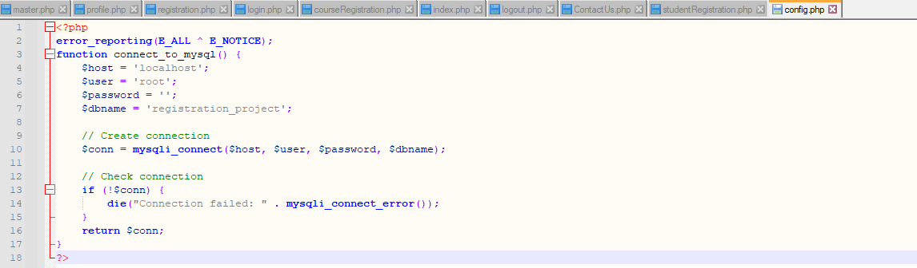

**Master.php (Navbar Generation RBAC):**

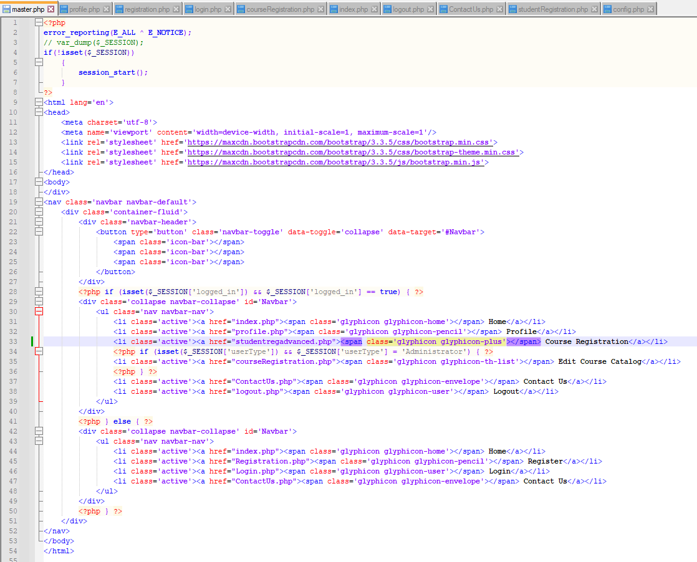

**Profile.php (Profile Page):**

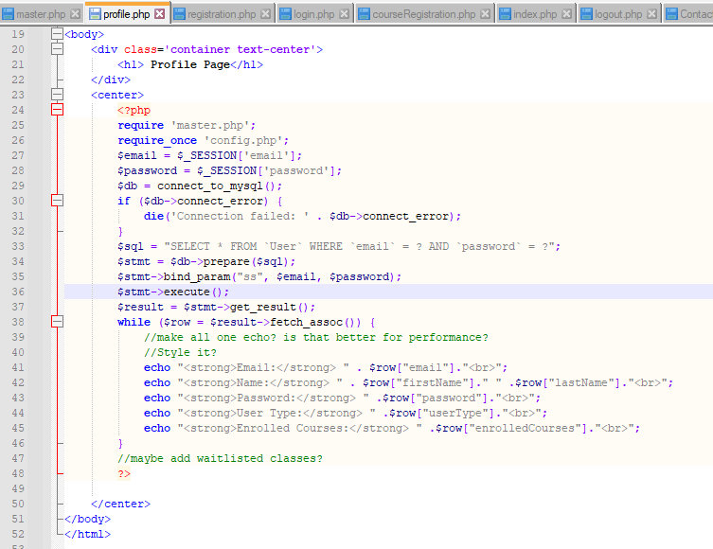

**Registration.php:**

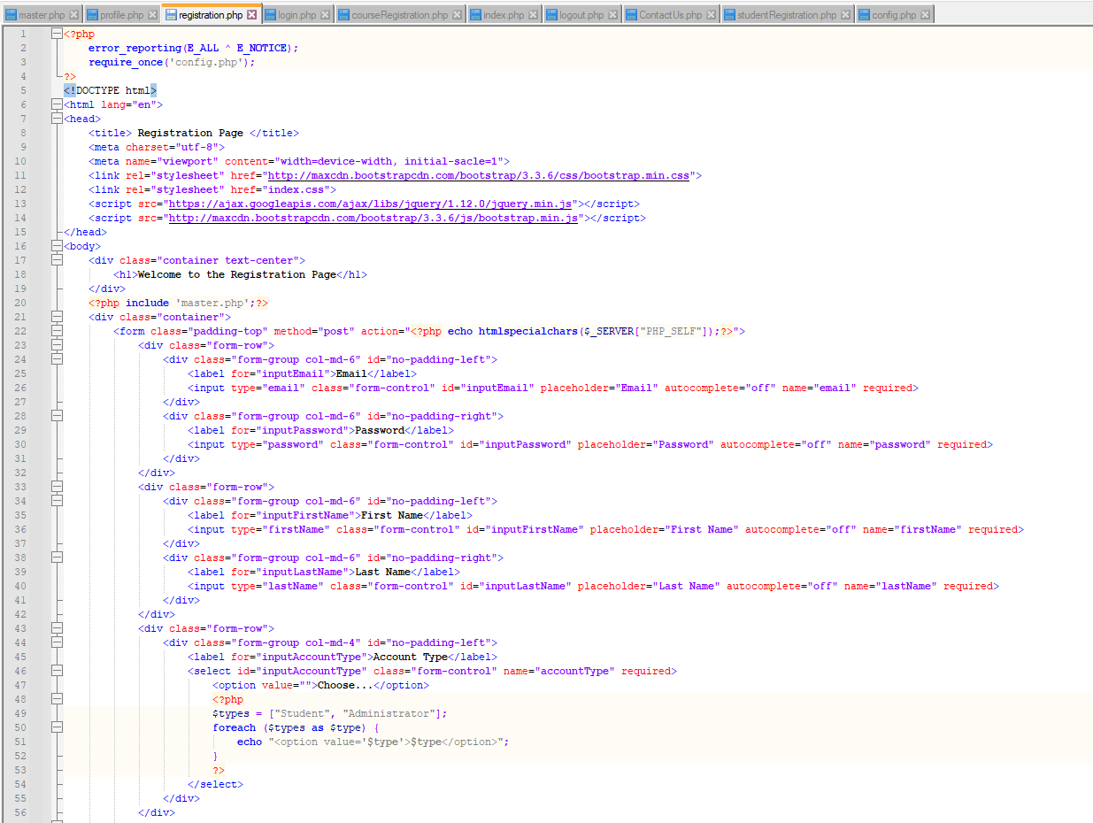

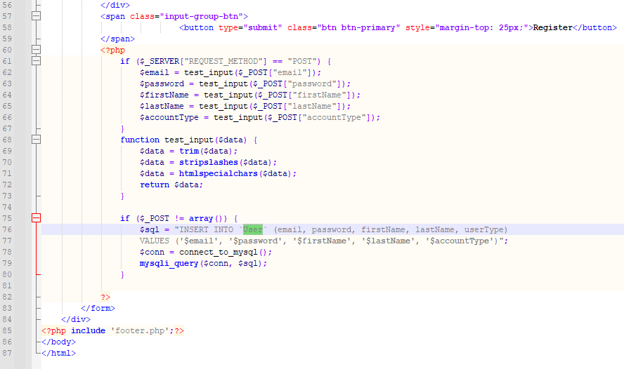

**Login.php: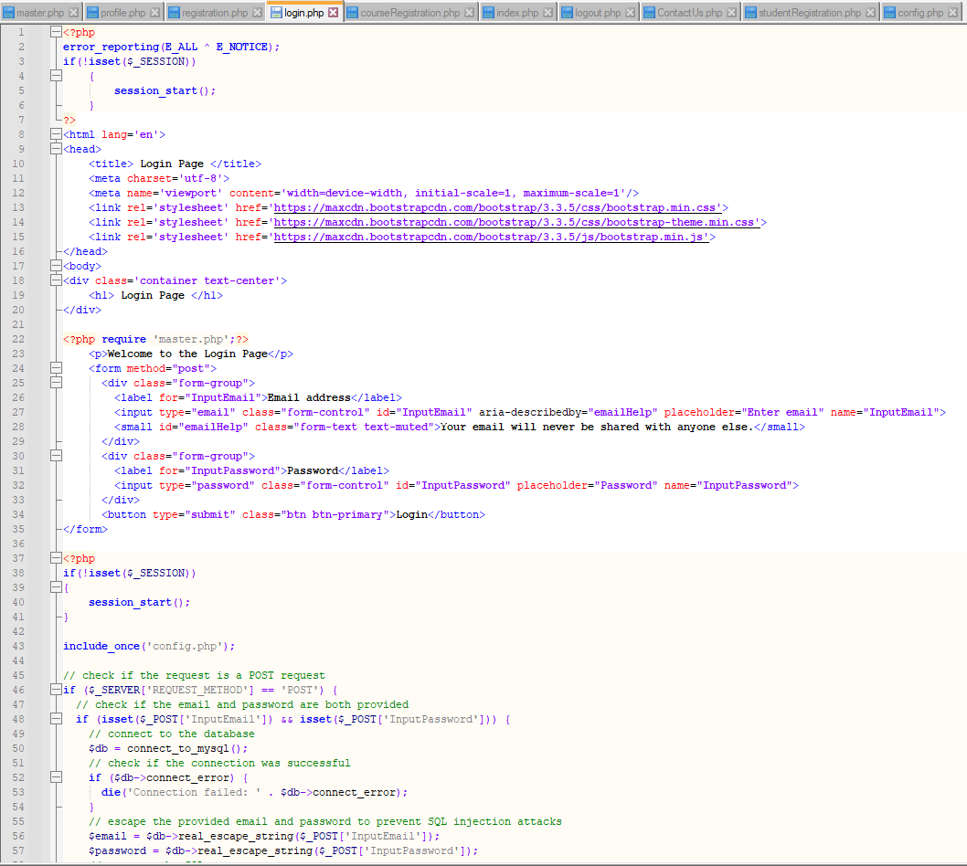Login.php Pt.2:**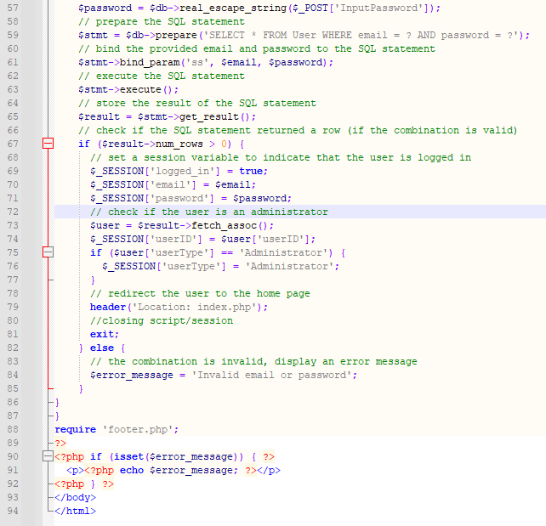

**CourseRegistration.php:**

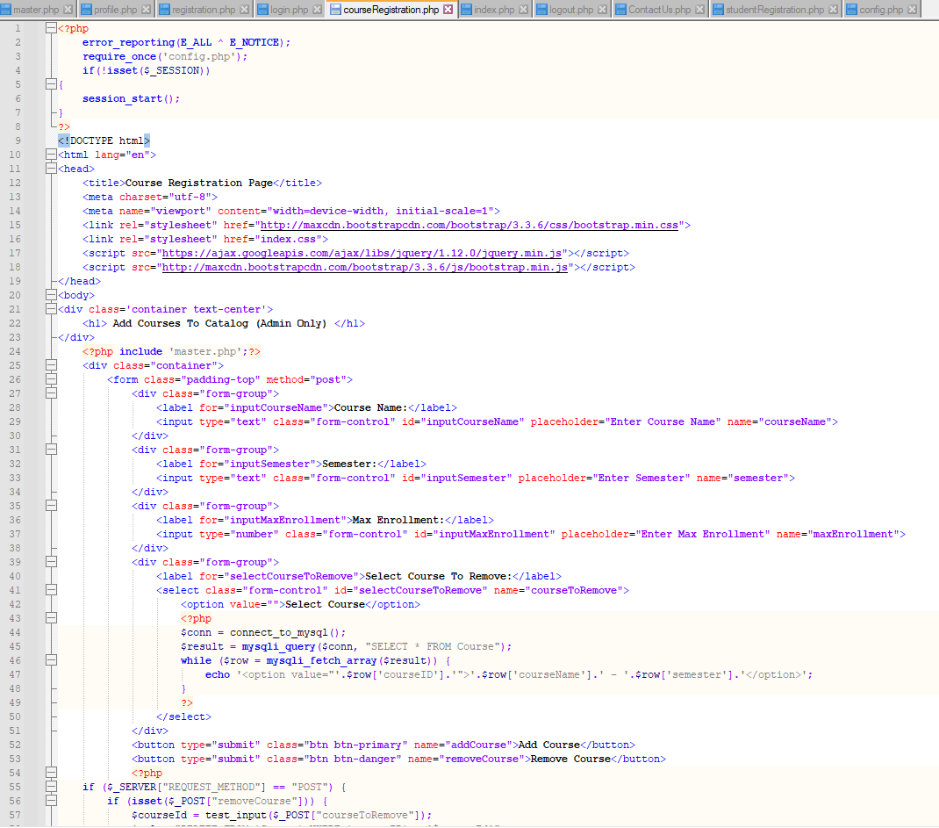

**CourseRegistration.php pt.2:**

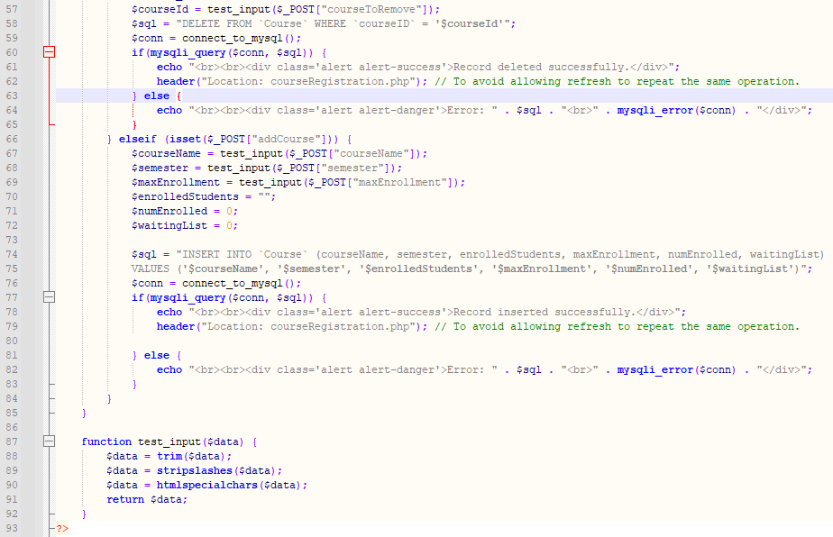

**Home Page (index.php):**

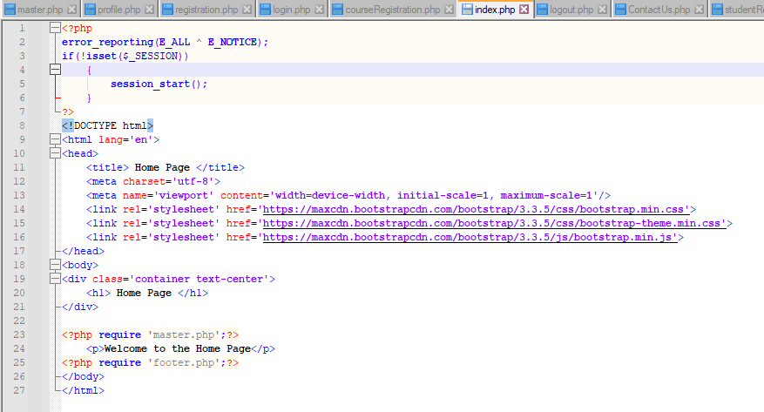

**Logout.php:**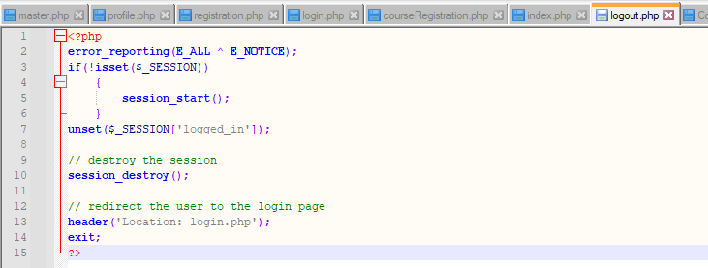

**ContactUs.php:  
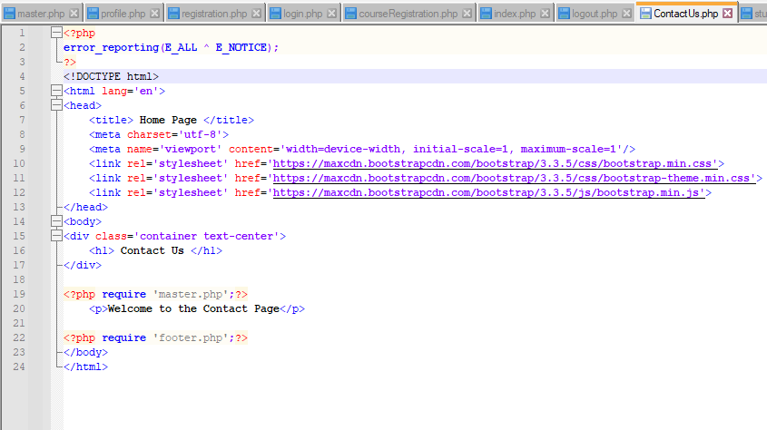**

**StudentRegistration.php Pt.1-4:**

